Nom : ……………………………. Date : …………………………….
CP

Lecture
Fiche
L16

http://www.i-profs.fr

Mots fléchés [z] s-z



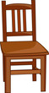

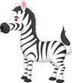
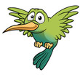
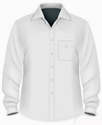
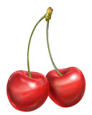

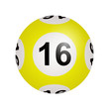



Nom : ……………………………. Date : …………………………….
CP

Lecture
Fiche
L16

Mots fléchés [z] s-z

raisin – chaise – zèbre – oiseau – cerise – chemise – zéro – seize - ciseau

Nom : ……………………………. Date : …………………………….
CP

Lecture
Fiche
L16

Mots fléchés [z] s-z

 |  |  |  |  |  | c
 |  |  |  |  |  | h |  |  |  | z
 |  |  |  |  |  | a |  |  |  | è
 |  |  |  |  |  | i |  |  |  | b
 |  |  |  |  |  | s |  | o |  | r
 |  |  |  |  | c | e | r | i | s | e
 |  |  |  |  | h |  |  | s
 | z |  |  | s | e | i | z | e
 | é |  |  |  | m |  |  | a
 | r | a | i | s | i | n |  | u |  | http://www.i-profs.fr
 | o |  |  |  | s
 |  | c | i | s | e | a | u

